**Free Reading Room cum Library Facility**

**Mohalla Quazi, Saharanpur**

**Aims and objectives**

* Creating and establishing educational environment among poor and educationally backward people in the neighboring localities of the premises.
* Bringing awareness about importance of education in human society.
* Restricting children to play in streets, watching excessive TV and wasting time without knowing their aims in life.
* Creating moral values among youth.
* Encouraging people to participate in social activities that benefit masses.

**Brief Methodology**

General atmosphere in slums and mohallas in small towns lack discipline and unless the children are given proper guidance, they fail in early classes and generally drop out of schools. To achieve above objectives, One Library facility was commenced in Mohalla Quazi Saharanpur in 2008 with approx. 40 students. As the word spread in neighborhoods, the number of students grew rapidly. Currently, there are more than 120 needy students from Nursery to 10th class, who are attending the two Centre’s located in Saharanpur to do homework, exam preparation and general help. They study in reading rooms and get guidance from teacher and visiting academic volunteers in different batches at the Centre. Young children of class nursery to 8th standard belonging to more than 50 educationally backward and financially poor families were targeted. These children were not having any guidance at home as parents were not educated.

Students are asked to attend the library cum reading room facility after school hours. They do their homework, learning work and self- study successfully under the supervision of one teacher and one supervisor. The facility helped in creating a positive atmosphere among students, very importantly of higher classes (9th-10th). One paid teacher along with a support staff is available for 4 hrs daily from 4 pm to 8 pm to assist the young boys and girls in completing the day to day homework.

Time to time the parents are requested to attend the motivating lectures to know how better environment may be created at home to uplift the children in the right direction

One room is enough for this purpose to accommodate around 50 children. Ideally masjid premises should be used for such purposes. However any rented or school premises may be used. All necessary furniture, white boards were bought to equip rooms adequately.

**Outcome:**

By providing free reading room library with all facilities like proper sitting arrangement, power backup and a small collection of important books to all class students, improvement in the results is observed. Students also became well behaved and confident with improvement not in academics but in cultural activities also.

**Further needs**

It is vital that the facility continues and students continue to get the support. Without such support, students’ performance will deteriorate sharply affecting their results. Some of them may thus drop out.

Such facilities should be multiplied and if possible. A mission should be started to extend maximum benefit to the needy people.

Data of dropped out students should be prepared in every mohalla as a large number of school going children discontinue their education after class VI onwards. A help from university students during summer vacations may be taken to accomplish this task under the mentorship of one or two local seniors.

.

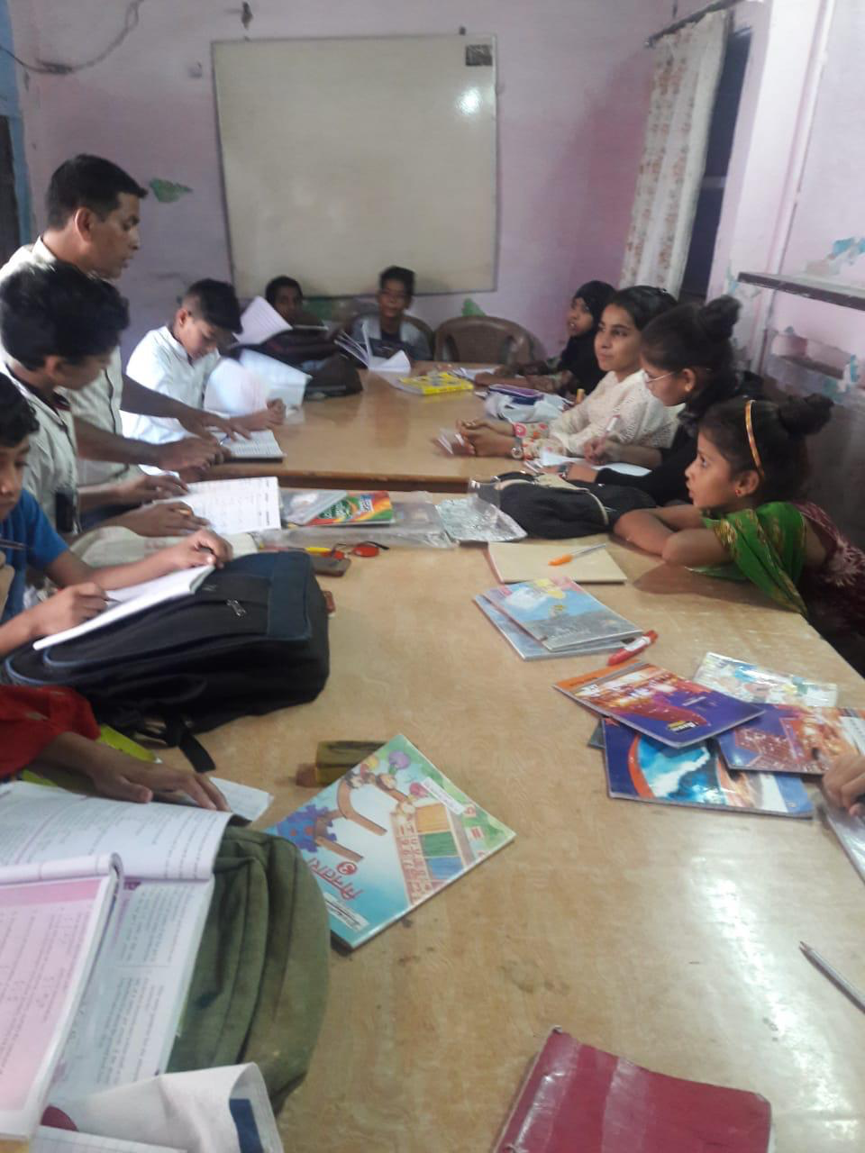

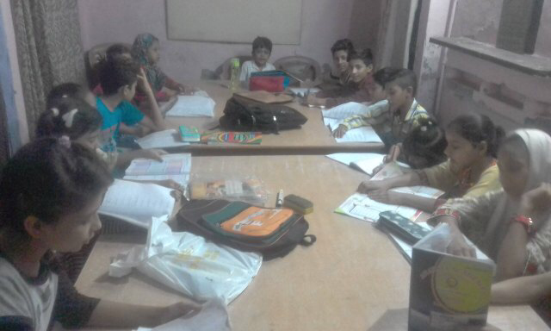

**A CULTURAL EVENT**

